EXPT NO: 5 | IMPLEMENTATION OF A RECURRENT NEURAL NETWORK (RNN) FOR TEXT GENERATION
DATE:

PRE-LAB QUESTIONS (PROVIDE BRIEF ANSWERS TO THE FOLLOWING QUESTIONS)

1. Explain the purpose of a Recurrent Neural Network (RNN) in processing sequential data.

- RNN is designed to process sequential data.
- It processes data step by step in order.
- It remembers previous information using a hidden state.
- It captures relationships between sequence elements.
- It is used for text, speech, and time-series data.

2. Why is an RNN considered an appropriate model for text generation tasks?

- Text is sequential, so word order is important.
- RNN remembers previous words using its hidden state.
- It learns patterns in sentences.
- It predicts the next word or character.
- Therefore, it is useful for generating text.

3. Describe the concept of sequence modeling in Natural Language Processing.

- Sequence modeling deals with ordered data.
- In NLP, words in a sentence form a sequence.
- The meaning of a word can depend on previous words.
- RNNs learn these relationships between words.
- It is used for translation, prediction, and text generation.

4. Explain the importance of tokenization during text preprocessing for RNN-based text generation.

- Tokenization divides text into smaller units called tokens.
- Tokens can be words or characters.
- Example: “I love AI” → “I”, “love”, “AI”.
- It helps create a vocabulary for the model.
- The tokens are then converted into numbers for the RNN.

5. Explain the significance of converting text into numerical representations before training an RNN.

- RNNs cannot directly process raw text.
- Text must be converted into numerical values.
- Each word or character is assigned a number.
- These numbers allow mathematical processing by the RNN.
- This helps the RNN learn patterns and predict the next word.
AIM
To implement a Recurrent Neural Network (RNN) for text generation and evaluate its ability to generate meaningful text by predicting the next word in a sequence.

SOFTWARE REQUIREMENTS
- Python
- TensorFlow or keras or PyTorch
- Google Colab
- GitHub
- Numpy
- Matplotlib

PROCEDURE
TASK A: DATASET PREPARATION
Perform the following tasks:
- Load the Tiny Shakespeare dataset from Hugging Face.
- Explore the dataset and examine the text samples.
- Convert the text into lowercase (if required).
- Tokenize the text into individual words.
- Build a vocabulary and assign a unique integer index to each word.
- Generate input sequences for next-word prediction.
- Apply sequence padding to obtain inputs of equal length.
- Split the prepared sequences into training and validation datasets.

SCREENSHOT OF CODE :

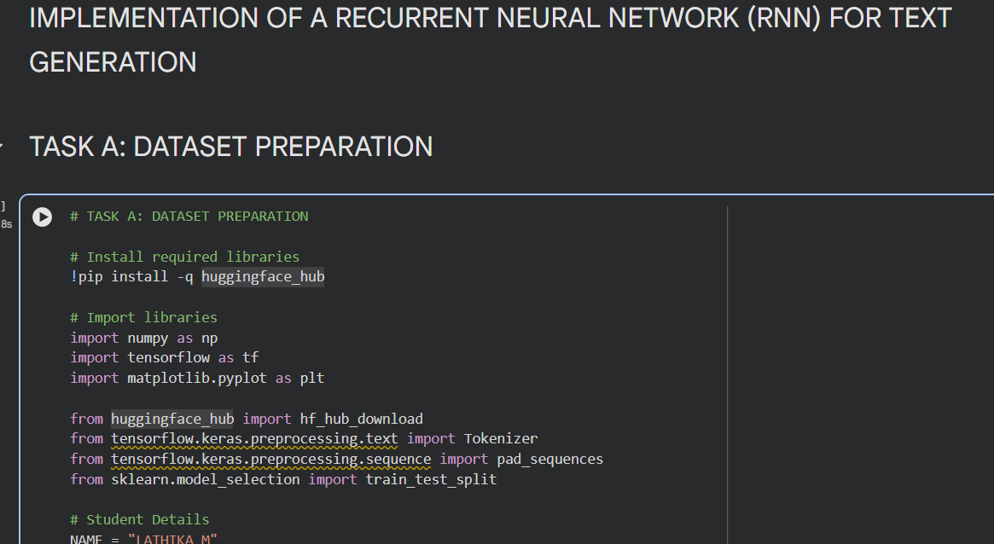
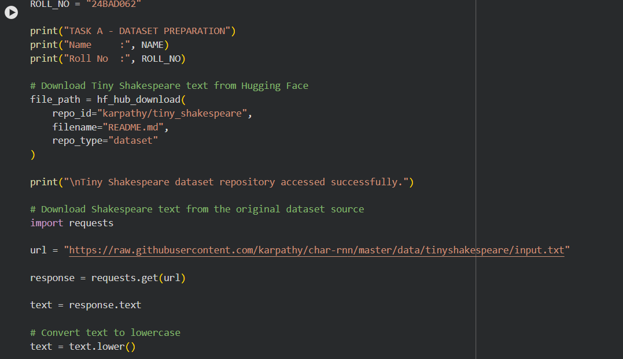

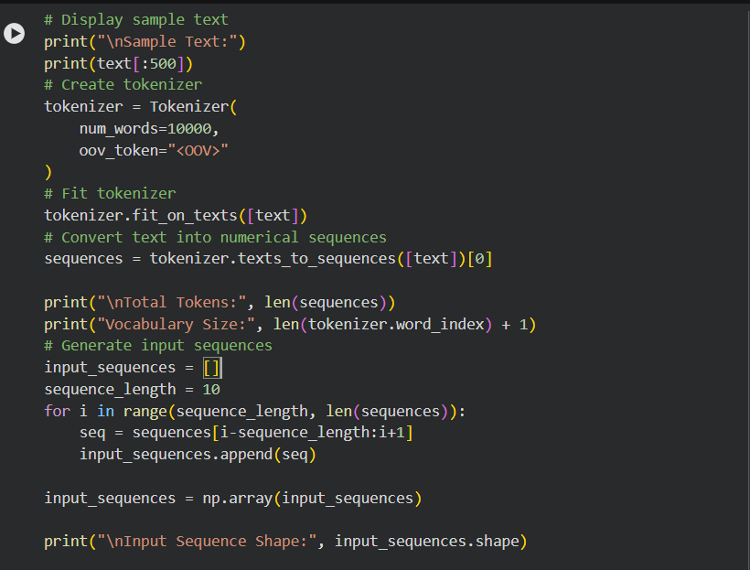

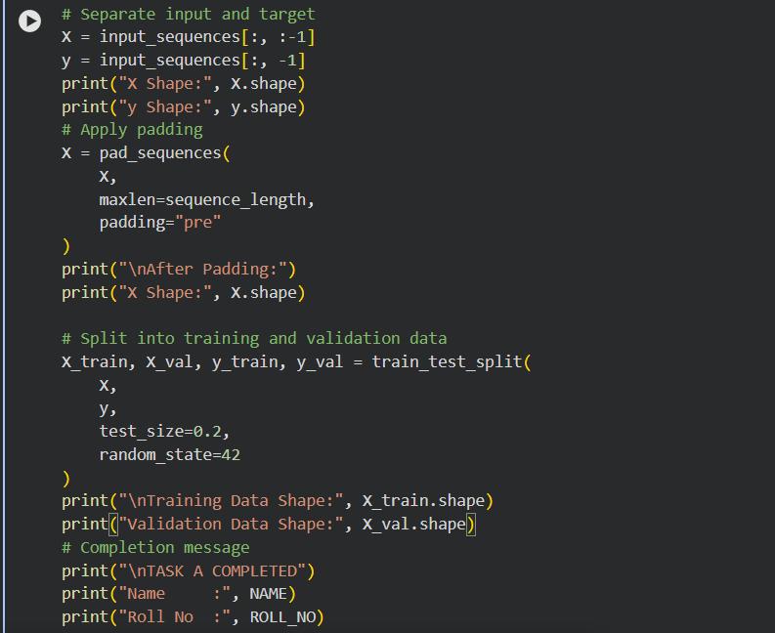

SCREENSHOT OF OUTPUT :

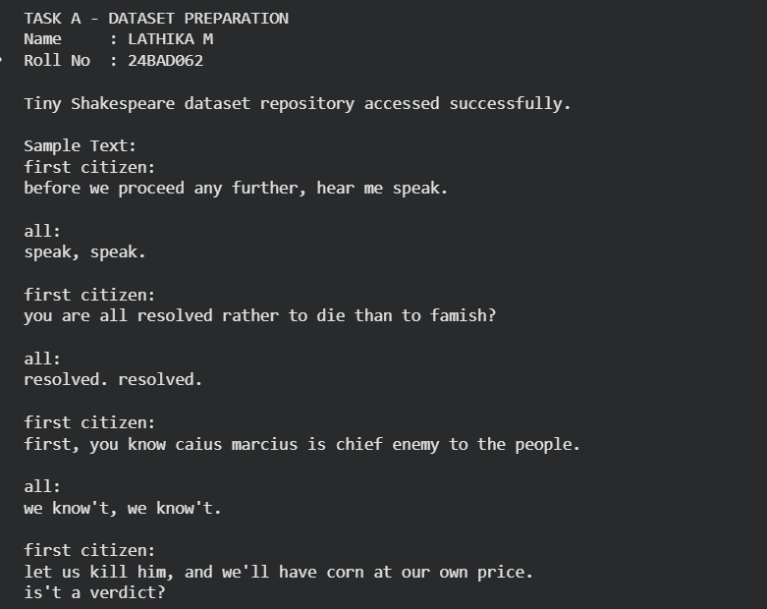

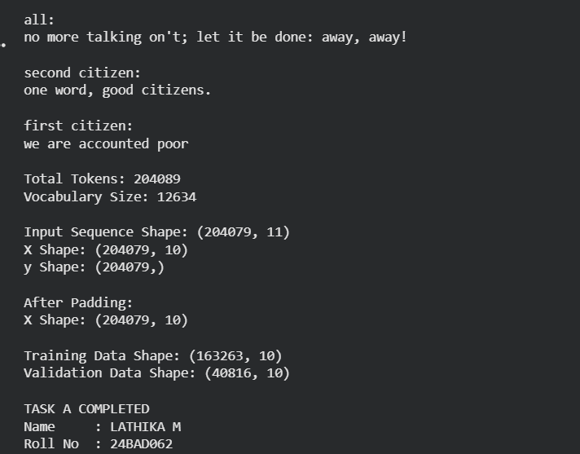

TASK B: IMPLEMENTING THE RNN MODEL

Perform the following tasks:

- Create an Embedding layer to convert words into dense vector representations.
- Add a Simple RNN layer to learn sequential dependencies in the text.
- Add a Dense output layer with Softmax activation for next-word prediction.
- Compile the model using an appropriate optimizer and loss function.
- Display the model architecture and summary.

SCREENSHOT OF CODE :

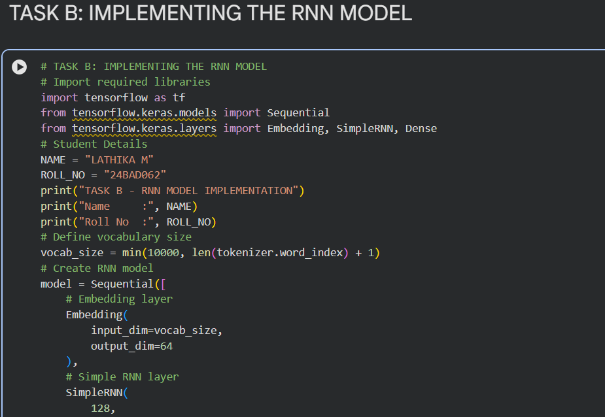

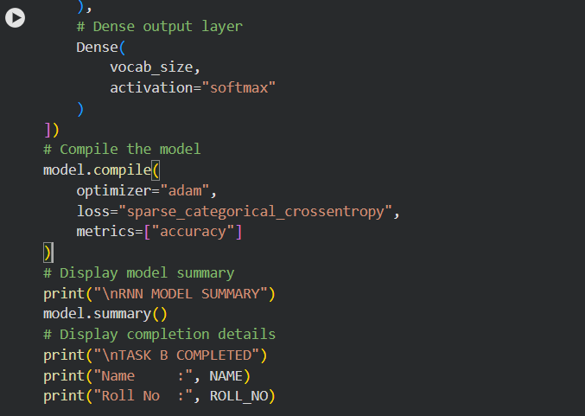

SCREENSHOT OF OUTPUT :

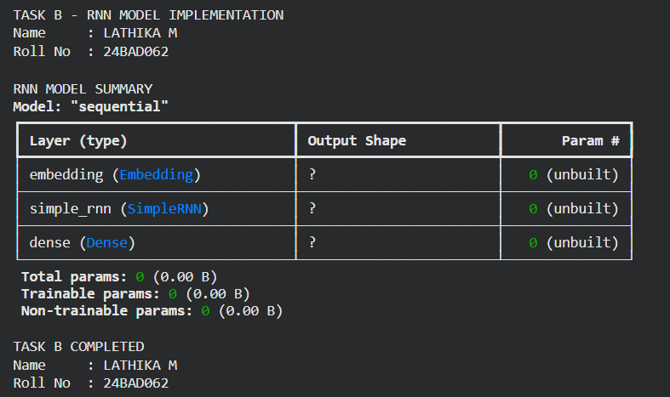

TASK C: RNN MODEL TRAINING AND PERFORMANCE EVALUATION
Perform the following tasks:
- Train the RNN model using the prepared training dataset.
- Validate the model using the validation dataset.
- Record:
  - Training accuracy
  - Validation accuracy
  - Training loss
  - Validation loss
- Visualize:
  - Accuracy vs. Epoch
  - Loss vs. Epoch

SCREENSHOT OF CODE :

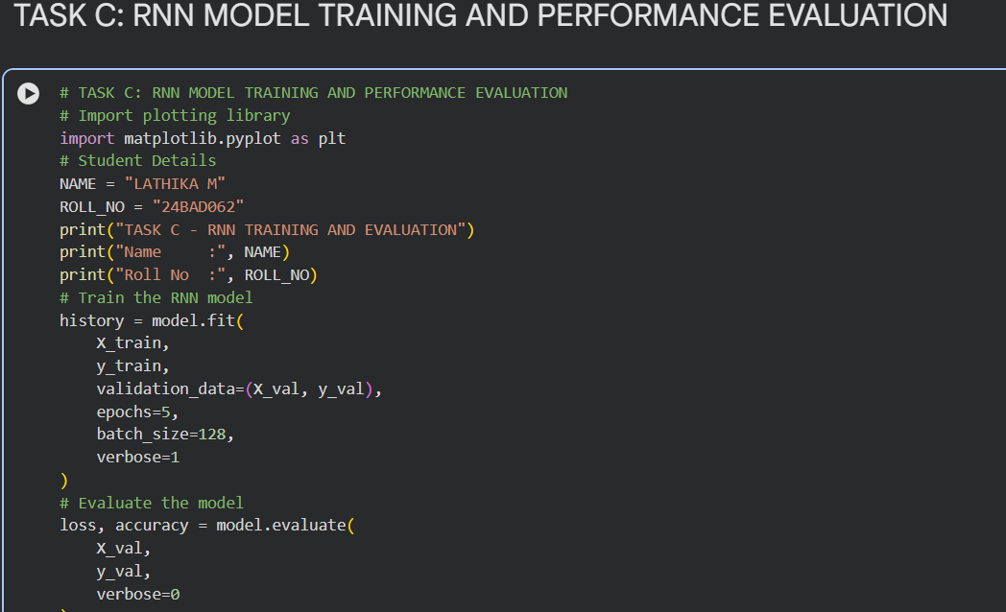

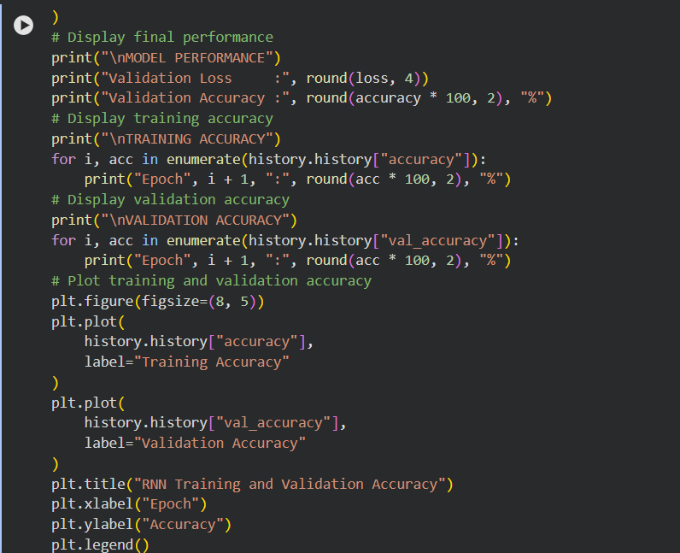

SCREENSHOT OF OUTPUT :

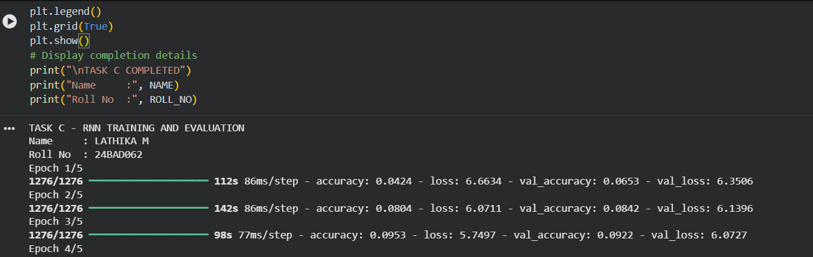

TASK D: DEEP LEARNING EXPERIMENT MANAGEMENT
Perform the following tasks:
- Provide a seed word or sentence as input to the trained model.
- Generate text by repeatedly predicting the next word in the sequence.
- Produce multiple text samples using different seed inputs.
- Compare the generated text for coherence and contextual relevance.
- Document the observations and upload the notebook to GitHub.

SCREENSHOT OF CODE :

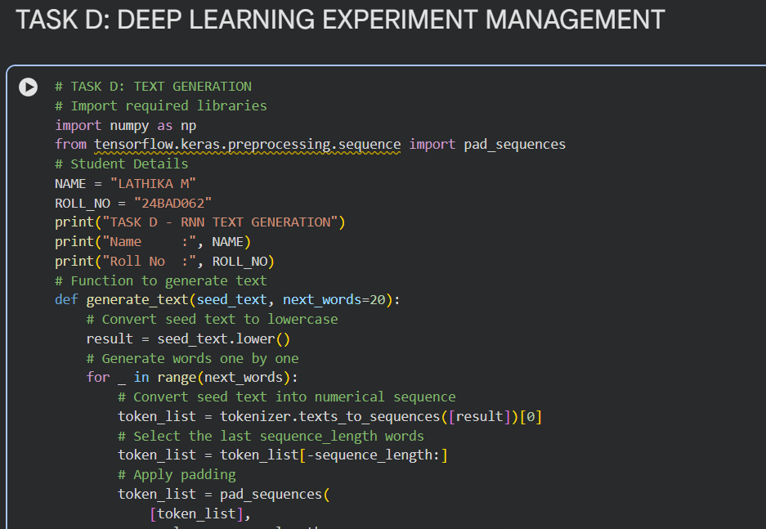

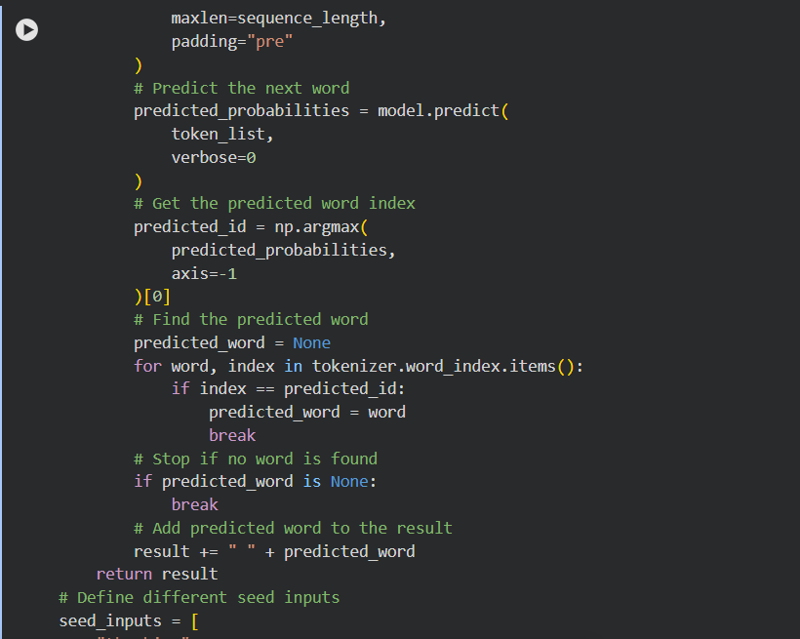

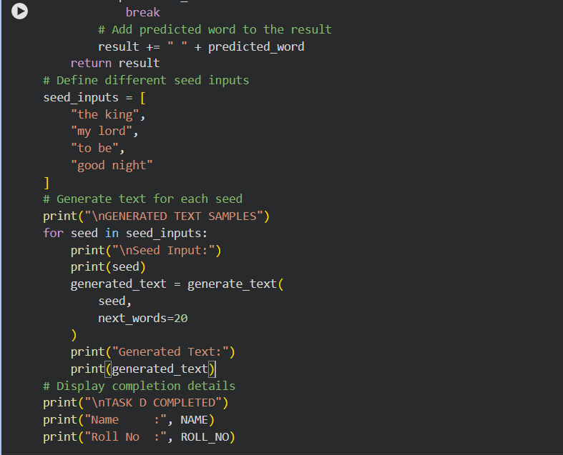

SCREENSHOT OF OUTPUT :

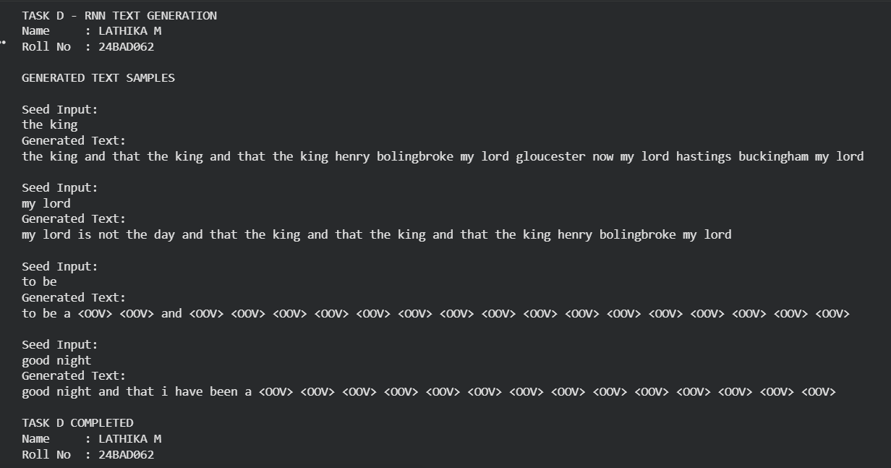
POST-LAB QUESTIONS (PROVIDE BRIEF ANSWERS TO THE FOLLOWING QUESTIONS)

1. Describe the role of the hidden state in an RNN during sequence processing.

- The hidden state stores information from previous time steps.
- It acts as the memory of the RNN.
- It is updated as each new input is processed.
- It helps the RNN understand the context of the sequence.
- It is useful for predicting the next word or character.

2. Discuss the effect of training an RNN model for an insufficient number of epochs.

- The model may not learn enough patterns from the text.
- Training accuracy may remain low.
- The generated text may be less meaningful.
- The model may underfit the training data.
- Increasing the epochs can improve learning up to a suitable point.

3. Explain the purpose of padding when preparing text sequences for RNN training.

- Padding makes all input sequences the same length.
- RNNs require inputs with consistent dimensions.
- Shorter sequences are filled with zeros.
- It allows sequences to be processed together in batches.
- Padding makes text data suitable for efficient RNN training.

4. Discuss one limitation of a Simple RNN when processing long text sequences.

- Simple RNNs have difficulty remembering information from long sequences.
- They can suffer from the vanishing gradient problem.
- Important information from earlier words may be lost.
- This reduces the model's ability to understand long-term context.
- LSTM and GRU can handle long-term dependencies better.

5. Discuss the effect of sequence length on the performance of the text generation model.

- Short sequences provide less context for prediction.
- Longer sequences provide more contextual information.
- Very long sequences require more memory and computation.
- An appropriate sequence length can improve text coherence.
- Therefore, sequence length should be chosen carefully for good performance.

ASSESSMENT
Description | Max Marks | Marks Awarded
Pre Lab Exercise | 5
In Lab Exercise | 10
Post Lab Exercise | 5
Viva | 10
Total | 30
Faculty Signature

